**You’ve joined a   
winning team**

**Information, support and resources for your role in Scouting**

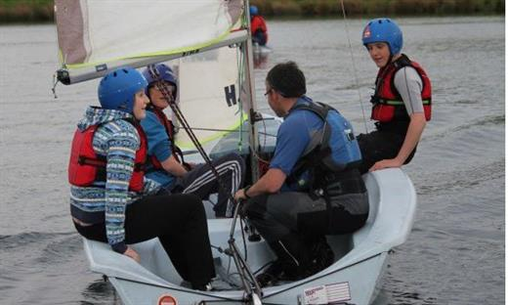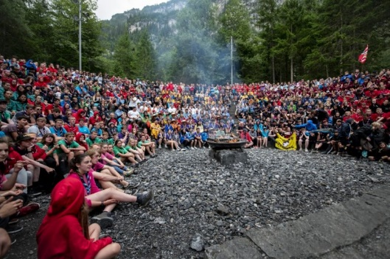

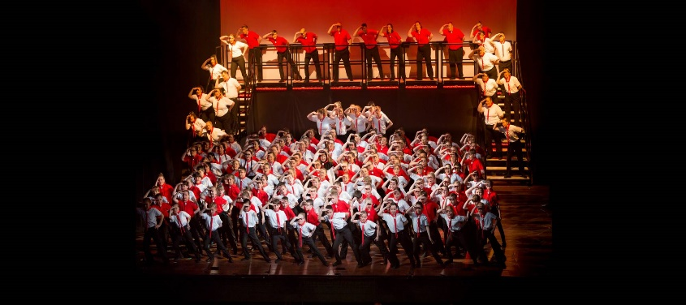



# **Welcome:**

**Welcome:**

Hi and welcome to this biggest family you will ever meet, that being of course the Scouts. Thank you so very much for volunteering your time to help the development of young people, your input and commitment is something that will hopefully shape their lives as well as your for many years to come. Without you we wouldn’t be able to offer the superb range of skills and activates that we do.

#### So what happens now?

Well we have put together this nifty little guide to help you in your journey as a new leader, where to go for help, some of the many terms we use, how to access scout training and what happens thought the appointment process. If there is something you feel we have missed – no problem just let us know as it might help others in the future.

We hope you enjoy your Scouting adventure with us and we look forward to seeing you at an event soon.

Justin and Annette  
Nottinghamshire County Induction team

**So when did scouting start?**



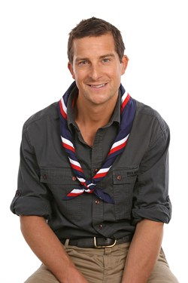In 1906 and 1907 Robert Baden-Powell, a lieutenant general in the British Army, wrote a book for boys about reconnaissance and scouting. This book, Scouting for Boys, was based on his earlier books about military scouting, with influence and support of Frederick Russell Burnham (Chief of Scouts in British Africa), Ernest Thompson Seton of the Woodcraft Indians**,**William Alexander Smith of the Boys' Brigade, and his publisher Pearson. In the summer of 1907 Baden-Powell held a camp on Brownsea Island in England to test ideas for his book. This camp and the publication of Scouting for Boys (London, 1908) are generally regarded as the start of the Scout movement.

More about our history can be found here:  
<https://scouts.org.uk/about-us/heritage>

# 

**How is Scouting structured?**

Scouts is split into counties, within those counties are districts and within those districts are your groups, let’s look more into those now. Don’t worry about the terms they will be explained later.

## **County Team** *Well some of them at least!!!*



Steve Cumberland  
DCC Support

Jack Beresford  
DCC Perception

Christine Sheard  
DCC People

Steve Tupper  
County Commissioner

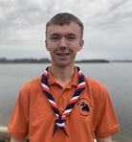

Jack Kellas  
County Youth Commissioner

Phil Herriot  
DCC Development

Jayne Burton-Naylor  
County Secretary

Moira Cordon  
County Chair

# 

**Staying safe in Scouting**

We want to make sure you are that not only the young people but also our adult volunteers are kept safe during Scouting activities. Hey we are all one big family and we want to look after everyone.

We have serval hand cards relating to different policies to help minimise risks, these are Yellow, Purple, Orange, Green and white

Yellow Card – Safeguarding young people - <https://archive.scouts.org.uk/media/996788/Yellow-Card.pdf>

Purple Card – Emergency Procedures <https://members.scouts.org.uk/documents/safety/Emergency%20card%20(Purple%20Card)%20screen%202019%20v3.pdf>

Orange Card – Young leaders information -<https://archive.scouts.org.uk/media/914973/VO-Orange-Card_March2018-V4-Screen.pdf>

Green Card – Alcohol Policy <https://members.scouts.org.uk/documents/Bianca/Green%20Card_May%202017%20V3%20WEB.pdf>

White – Staying safe checklist <https://members.scouts.org.uk/documents/SafetyArchive/Leaders%20Checklist%20Sept%202012%20_Downloadable1.pdf>

You should be given these when you first Join or at very least your appointments meeting, if you have not been given colour cards - please let us know and we send them out directly

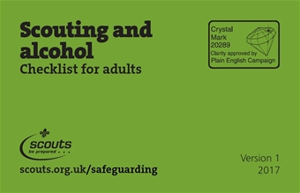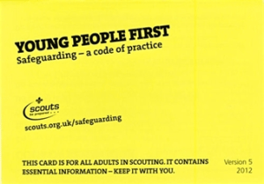

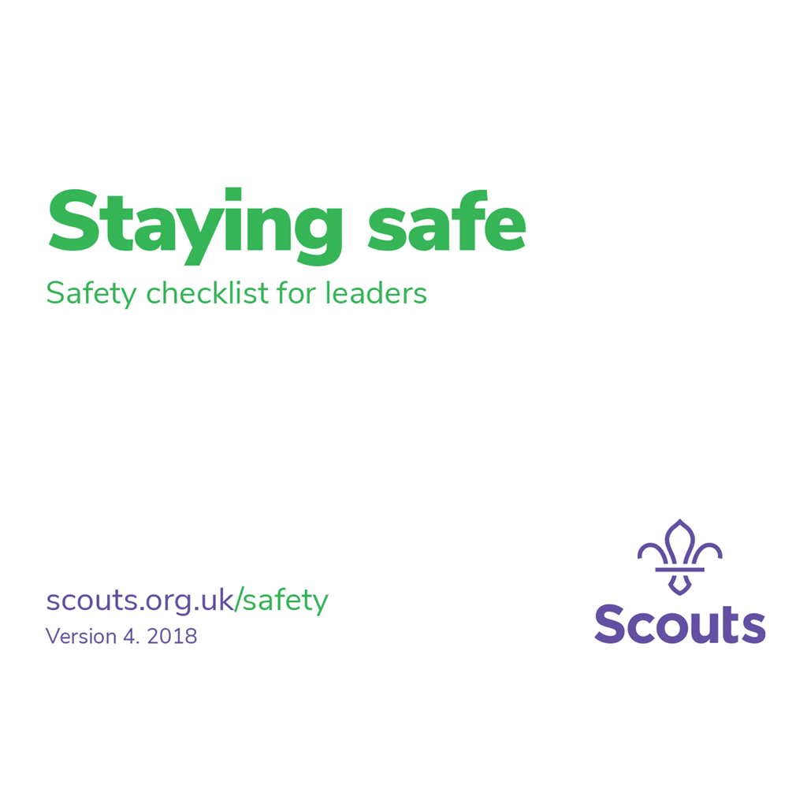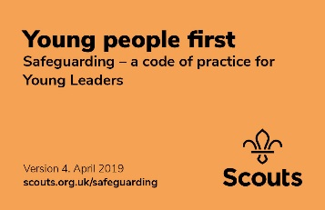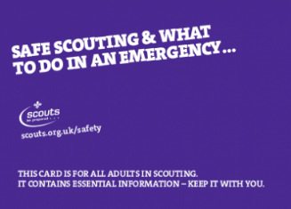

#### 

**Key terms:**

Yes we are just like anywhere else and we are suckers for using abbreviations, so you might know but if not here is a handy tip on what the most common ones mean….

|  |  |
| --- | --- |
| Term | Meaning |
| CC | County Commissioner – Looks after everything in Nottinghamshire |
| ACC | Assistant County Commission – Assist with specific aspect of the county e.g. sections, international, training etc. |
| DCC | Deputy County Commissioner – assist the CC with the running of the County |
| DC | District Commissioner – looks after everyone in the Local District of which there are 9 in Nottinghamshire |
| DDC | Deputy District Commissioner – assist the DC with the running of the District |
| ADC | Assistant District Commissioner – Assist with specific aspect of the district e.g. Beavers, Cubs, Events |
| DESC | District Explorer Scout Commissioner – Looks after all the Explorer and their leaders in a district |
| GSL | Group Scout Leader – Looks after and over sees the running of your local group. |
| DLTM | District Local Training Manager – The person look looks after all your training needs |
| DYC | District Youth Commissioner – normally someone under the ages of 25 who goes out to the sections and is a voice for the young people with the District |
| DNC | District Network Commissioner – looks after the network section 18-25 year olds within your district. |
| TA | Training Advisor – the person who mentors you though your Scout training and validates your learning |
| Risk Assessment | A term used to make sure we have looked into any associated risks when planning and running activates |
| GDPR | General Data Protection Regulation – A rule that looks at the way we store and transfer personal data and information |
| Jamboree | A worldwide camp typically happens every 4 years bringing together thousands of scouts from across the globe |
| NESST Walk | An overnight Activity in January involving challenges along the way, open to all youth sections and leaders |

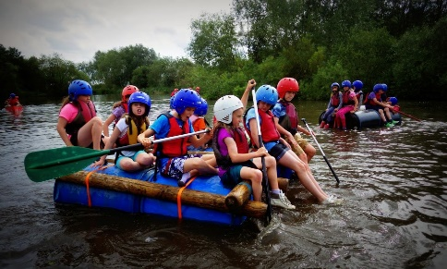

# 

**Your role**

#### Section Leader:

This is the person who is overall responsible for the section be it Beavers/Cubs/Scouts or Explorers. They report to the GSL and have a team of leaders (assistant leaders/sectional assistants) who help them plan and run the program

#### Assistant Leader:

A leader who help the sectional leader with the running planning and execution of the Program. They report to the Section leader and are responsible for the young people in the section.

#### Sectional Assistant:

Someone who does not want to be a fully wanted leader that can come and help out at a section, they cannot run a section night without at least 2 other warranted leaders though. They assist in the running of programs and report to the Section leader.

#### Committee Member:

An adult elected to the board that assists in the running of the business side of the group such as treasurer, secretary, chair or a parent presenting a section

# 

**So what happens next ?**

Well firstly you need to go through what is called the appointments process.

You have already kicked this off by showing interest in wanting to join as a Leader/Helper.   
Your local appointment team will arrange for a record to be created for you and will complete DBS records checks and provide the name of 2 references  
Once the records and references come back you will be invited to addend an appointments meeting – don’t worry though these are just informal chats to find out what you know about scouting, why you want to join and what you can bring to the table, there are no right or wrong answers here and it’s a great way for you to meet people in your district.

Between having your initial chat and applying as a leader and your actual appointments meeting, it is expected you watch 2 videos on scouting basics, these are actually 2 of the modules of the leader training scheme. It means that you have some knowledge about scouting before you attend your appointment and it means on the same night you can validate 2 of your units and go straight to a full appointment.

**Training**



**How the Adult Training scheme works**

The Scouts requires each adult in Scouting to demonstrate a range of knowledge, skills and attitudes that are relevant for their role in Scouting. Different skills and knowledge are required for different roles so the Adult Training Scheme is broken into a range of modules. Each adult is required to do the modules for their role in Scouting.

There are 2 key elements to the Adult Training Scheme learning and validation

#### Learning

Learning provides the opportunity to gain or improve the knowledge and skills you need to be a leader and be successful in your role. The methods used for learning vary and you can pick how you want to complete the learning to fit with your individual learning style and the knowledge and skills you may already have. In Nottinghamshire we aim to make learning fun, information.

#### Validation

This is the process of demonstrating to your Training Adviser (TA) that you can meet the objectives of the module. This can be done through a variety of methods from your TA observing you in your Scouting role, providing evidence such as a witness testimony, or discussing with your TA. Evidence should be something you do as part of your role in Scouting and should not generate any extra work.

**The Training Scheme**

#### Getting Started

Getting Started is made up of six modules which must be completed by all adults before the adult can be fully appointed. There is a seventh module for Executive Committee members / trustees.

Getting Started needs to be completed within five months of the role start date, as recorded on Compass. These modules are:

· Personal Learning Plan (02)

· Essential Information (01)

· Safety

· Safeguarding

· Tools for the Role: Section Leaders (03) or Tools for the Role: Managers and Supporters (04)

· General Data Protection Regulations (GDPR)

· Trustee Introduction (for Executive Committee members)

These modules may be completed in any order. In order to ensure that adults can complete Getting Started within the required timescale (five months) the modules are available as online learning.

Wood Badge

For Section leaders, assistant section leaders, managers and supporters a Wood Badge will need to be completed.

The Wood Badge is the internationally recognised Scouting training insignia awarded to adults by Headquarters to denote completion of the training required for their role. The Wood Badge consists of two wooden beads threaded onto a leather thong which is worn with Scout uniform.

The modules required to complete a wood badge is tailored for the role

Training for all appointments

Module 12a – Delivering a Quality Programme

Module 5 – Fundamentals of Scouting

Module 7 – Scouting for all

Module 10 – First Aid

Module 11 – Administration

Training for Section and assistant section leaders

Programme modules

Module 12b Programme Planning

Module 17 Running Safe Activities

Module 16 Introduction to Residential Experiences

Module 18 Practical Skills

Module 19 International

People Modules

Module 14 Supporting Young People

Module 15 Promoting Positive Behaviour

Module 13 Growing the Section

Module 9 Working with Adults

Module 8 Skills of leadership

For Managers and Supporters

There are 6 Core Skills areas plus safety to be completed for Managers and Supporters to gain a wood badge.

The learning is split into 14 Independent Learning modules to be completed, the learning methods including e-learning, videos, learning guides, workbooks and information sheets. There are 3 skills courses that can be attended to support the independent learning modules.

Core Skill areas – each area has a number of validation criteria.

· Managing Time and Personal Skills

· Achieving Results

· Providing Direction

· Working with people

· Enabling Change

· Using Resources

· Safety

**Training Courses available in Nottinghamshire**

Induction Training: For new leaders and covers Modules 5-9, 11-19

Skills for Life 2 - Getting Going : Why we do Scouting and skills required to be a leader (Modules 5-9, 11, 14 and 15)

Skills for Life 3 – Getting On : Planning and delivering programmes for your section (Modules 12, 13, 16-19)

Planning and Running a Residential Experience: (Modules 16, 18 and 38)

First Response  Module 10A  First Response Theory – Online and virtual sessions, Module 10B Practical assessment, Needs to be renewed every 3 years, external qualifications are recognised but must meet the criteria of the Scout Association.

E-learning

**Getting Started Modules:** [Module 1](https://members.scouts.org.uk/training_module/essential_info_16102014/), [Module 3](http://www.surveygizmo.com/s3/2310979/Module-3-Tools-for-the-Role-Section-Leaders/), Safety, Safeguarding, GDPR and Trustee Introduction

**Section Leader Training:** [Module 5](http://members.scouts.org.uk/training_module/scouts-fundamentals-04-06-14/#/menu/m05/) and [Module 12a](https://members.scouts.org.uk/training_module/deliver_quality_programme-16122015/)

**Manager and Supporter Training:** [Independent Learning](https://members.scouts.org.uk/supportresources/4660/)

**Work books:**

**Section Leader Training:** [Module 7](https://members.scouts.org.uk/factsheets/ASW7.pdf), [Module 11](https://members.scouts.org.uk/documents/Adult_Training/Module11/Module%2011%20Workbook%20v4.0.pdf), [Module 13](https://members.scouts.org.uk/documents/Adult_Training/Module13/Module-13-workbook-forms-edit.pdf), [Module 14](https://members.scouts.org.uk/factsheets/Module%2014%20workbook.pdf), [Module 15](https://members.scouts.org.uk/factsheets/Module%2015%20workbook.pdf) and [Module 17](https://members.scouts.org.uk/documents/Adult_Training/module17/Module%2017%20Workbook%20-%20June%202018.docx.pdf)

**Manager and Supporter Training**: [Independent Learning](https://members.scouts.org.uk/supportresources/4660)

**One to one or small group sessions:** Run locally in districts to meet individual needs

What support is available

When you take on your role you should be assigned a Training Adviser (TA) to support you through your training. This may be your Group Scout Leader, or another leader in your group or district.

You will find useful validation documents plus information on all the training offered and what you actually need to complete at our training website <https://training.notts-scouts.org.uk>

# Faq icon Stock Vectors, Royalty Free Faq icon Illustrations ...

**FAQ’s, Help & support**

#### Will I get paid/expenses?

The Scout Association is a voluntary organisation, and you will not be paid for your role. However, no adult should feel that cost prohibits them from taking up a role in Scouting, and we are committed to reimbursing out of pocket expenses for all volunteers. You should speak to the Group Scout Leader to find out how this works.

#### Where does religion fit into Scouting?

#### The Scout Association does not identify itself with any one religion, we are an open organisation that welcomes everyone whether they have a religion or not. We do however encourage true Scouting values.

When can I wear my uniform?

Straight away is the answer, as soon as you join the scouting movement you are entitles to wear your uniform.

#### Who is responsible for administering first aid if there is an accident?

All trained adults in Scouting should have an up to date first aid certificate of First Response level or equivalent (Mod 10) and are responsible for the young people in their care. On a camp or activity one person should be designated first aider. If an incident requires any consultation with or treatment by a doctor, dentist or hospital the Information Centre should be notified.

#### What insurance do I/the young people have?

All Members of The Scout Association have personal accident insurance and legal liability cover whilst on scouting activities. Current details can be obtained from Scout Insurance Services on 0845 0945 702 or [www.scouts.org.uk/insurance.](http://www.scouts.org.uk/insurance) You can also talk to if you have any questions.

#### Can I take young people on camp straight away?

Every night’s away event for young people in Scouting must be led by someone who holds a Nights Away Permit. Other leaders attending the event do not need a Nights Away Permit. Speak to Group Scout Leader to find out more about this, and to find out who your Nights Away Adviser is.

**Still need more advice or pointing in the right direction? No problem**

If you have a query re your induction into Scouting please contact Justin or Annette in the first instance on [Justin.fisher@notts-scouts.org.uk](mailto:Justin.fisher@notts-scouts.org.uk) or   
[Annette.daykin@notts-scouts.org.uk](mailto:Annette.daykin@notts-scouts.org.uk)

If you have query about your district, please speak to your District Commissioner

Any general queries we have some lovely people at the county resource centre that can help email [office@notts-scouts.org.uk](mailto:office@notts-scouts.org.uk) or call **0115 9523617**

**UK Scouts website** - [www.scouts.org.uk](http://www.scouts.org.uk)

**Nottinghamshire Scouts Website** - [www.notts-scouts.org.uk](http://www.notts-scouts.org.uk)

**Scout Shop** - <https://shop.scouts.org.uk/>

**Scout Polices** - <https://scouts.org.uk/por>